Ideation Phase Empathize & Discover

Date | 04 July 2026
Team ID
Project Name | Personalized Networking Assistant
Maximum Marks | 4 Marks

Empathy Map Canvas:

The Empathy Map Canvas helped our team understand the needs, thoughts, and challenges of users attending networking events. By analyzing the user's perspective, we identified the difficulties they face in starting conversations and building professional connections. These insights guided the development of the Personalized Networking Assistant, enabling us to design features that generate personalized conversation topics, provide reliable information, and improve users' confidence during networking interactions.

Example:
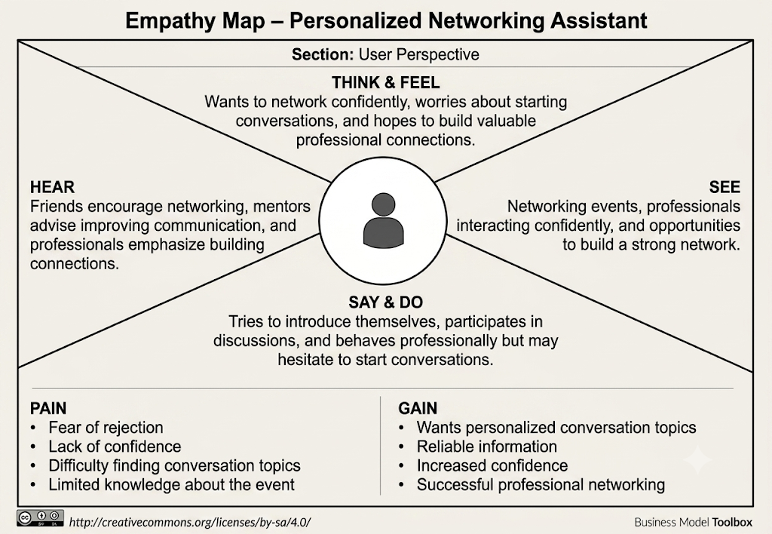

Example: Empathy Map – Personalized Networking Assistant

